# **CREDIT ANALYSIS**

TEAM NUMBER: 02

TEAM MEMBERS: Sumanayana Konda (002786769)

Sreeja Vangoori (002788038)

**INTRODUCTION:**

Credit analysis refers to the process of determining whether an individual petitioning for a loan or entering a debt has the financial health and resources to service the debt in the future thorough their history with credit. According to the Personal Loan Statistics from Lending Tree, “20.4 million Americans have a personal loan as of the first quarter of 2022”. In the banking industry, the two most urgent problems are: How dangerous is the borrower? 2) Considering the danger, should we lend to the borrower? The borrower's interest rate is determined by the answer to the first query. The riskiness of the borrower is tested, among other things, by the interest rate; the greater the interest rate, the riskier the borrower. The interest rate will then be used to determine if the applicant qualifies for the loan. Loans are given by lenders (investors) to debtors in exchange for the promise of interest-bearing repayment. In other words, the lender only receives payment (interest) if the borrower pays back the loan. But regardless of whether they don't pay back the loan, the lender loses money. In exchange for a promise to repay, banks lend money to clients. Some people would stop paying their bills because they were unable to do so for various reasons. To lessen the likelihood of failure in the event of a default, the bank keeps insurance. The entire loan amount may be covered by the insured sum or only a portion of it. Based on the data, banking systems utilize manual techniques to decide whether a borrower is qualified for a loan. Despite being largely effective, manual processes fell short when there were a lot of loan applications. Making a choice at that moment would require much time. As a result, it is possible to determine a customer's loan status using the loan prediction machine learning model. The loan prediction machine learning model can therefore be used to determine a customer's loan condition and develop plans. The key characteristics of a borrower that affect the customer's loan status are extracted from and introduced by this model. Eventually, it results in the desired performance (loan status). The work of a bank manager is made easier and faster by these reports.

* **BACKGROUND:**

**Credit analysis in other words is a financial analysis a potential investor or managers perform on their or other companies, institutions and organizations that are involved in money lending activities to measure the debt issuers capability to meet the debt commitments. It is a task of estimating the range of default risk that comes with the activity of debt issuing and investing in these organizations. Utilizing cash flows, financial data, and financial projections of a company an analyst can predict the ability of the organization to fulfill their obligations with debt. Details like credit scores, Alternative Minimum Tax and so on are also included in this analysis for better accuracy. The result of the analysis will give a clear understanding of what is the risk of issuing money to an individual and in turn can be used to determine whether to extend the credit or loan money. Credit analysis is also used to predict when a bond issuer's credit rating will change. An investor or manager might make a profit by speculating on debt rating changes by identifying enterprises that are about to occur.**

* **MOTIVATION:**

Each year numerous applications are sent out to banks and similar organizations, requesting for loans with various backgrounds and circumstances. The number of applications often make it difficult for the employees to analyze whether an application meets the requirements and needs to get an approval quickly and thoroughly without an external help. Consequently, a good deal of undeserving candidates gets their loans sanctioned while many efficient applicants are awarded with a rejection. The motivation behind this project is to prevent this from happening anymore in the future.

* **GOAL:**

The goal of this project is to produce a Machine Learning and Data Analysis model capable of processing great quantity of loan requesting applications and make an analysis of an applicant’s ability to service a debt and the conditions effecting the conclusion.

**METHODOLOGY:**

Perusing credit analysis is a difficult task owing to the size of dataset and the features directly effecting the calculation. Here, it is necessary to identify the loan application patterns in order to determine fraud applicants or potential clients who cannot repay the loans despite having spotless records in their portfolio. There are some cases where the applicants may not possess credit history and new to the credit system which makes the determination whether they are good or bad clients in the future hard. Hence, it is important to build a strong model that can expand the number of sanctions to the clients with maximum chance of loan repayment and has the capacity to build good financial portfolio. Numerous methods were introduced to accomplish the task, each better than the other with incredible results. The dataset selected is large and consists of many features important to the evaluation of the credit analysis. Various Machine Learning algorithms like Logistic classification, Naïve Bayes Classification, XGboost classifier, Ada-Boost classifier, Decision tree Classifier, Random Forest Classifier and Multi-Layered Perceptron are the algorithms filtered out to complete the process of filtering applications worthy to get a loan approval. The algorithm which is adept at producing an estimation with satisfying accuracy, precision, recall, F1 score, AUC – ROC curve and least error will be concluded to be the best one and eventually will be utilized to build a model.

* **DATASET PREPARATION:**

The dataset is obtained from Kaggle, named “Credit Analysis”. It is a dataset detailing the previous and present data of loan applications from an unnamed bank utilizing Risk Analytics. The dataset spans over 122 columns detailing multitude of categories describing the credit card and usage information, personal details, economic, regional and educational background, medical and criminal history and finally the employee’s opinion of the clients. By the end of the analysis, it is expected that more than 70 columns will be dropped depending on their correlation score while the remaining 50 columns will hold a major impact on the model and its results.

The following diagrams display the columns and data of the dataset before preprocessing and data manipulation.

The Columns:

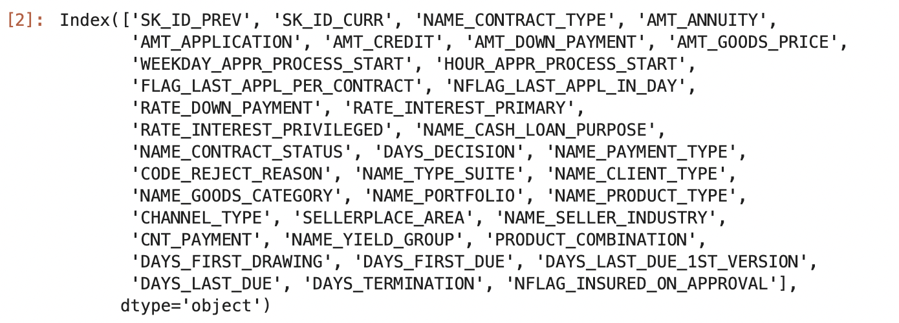

The Dataset:

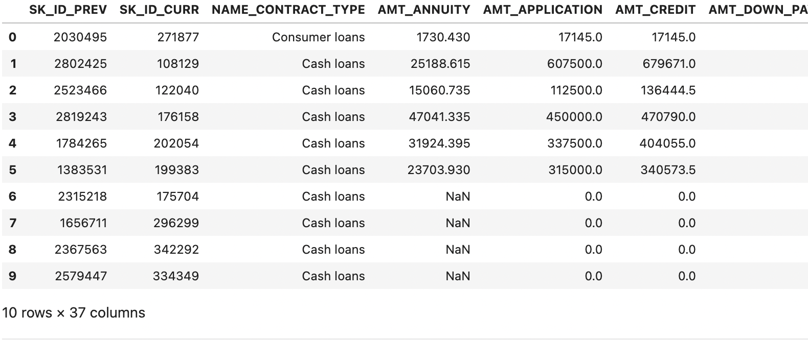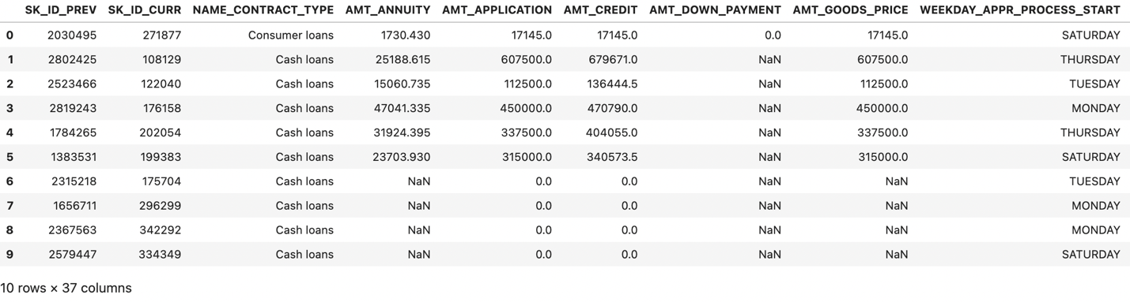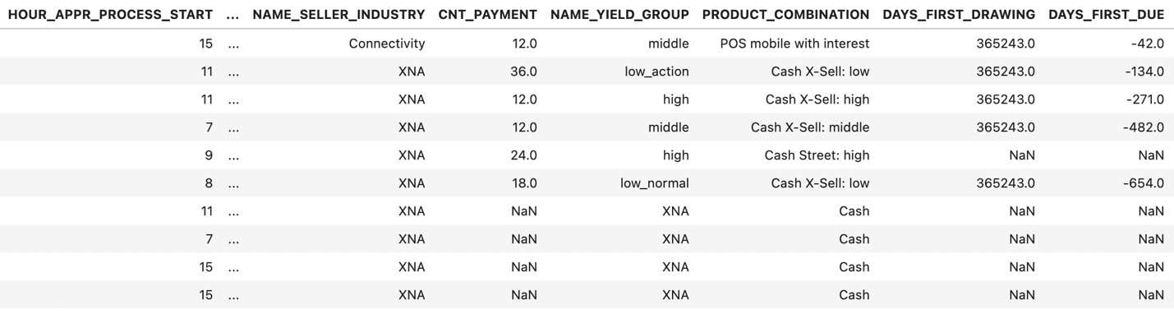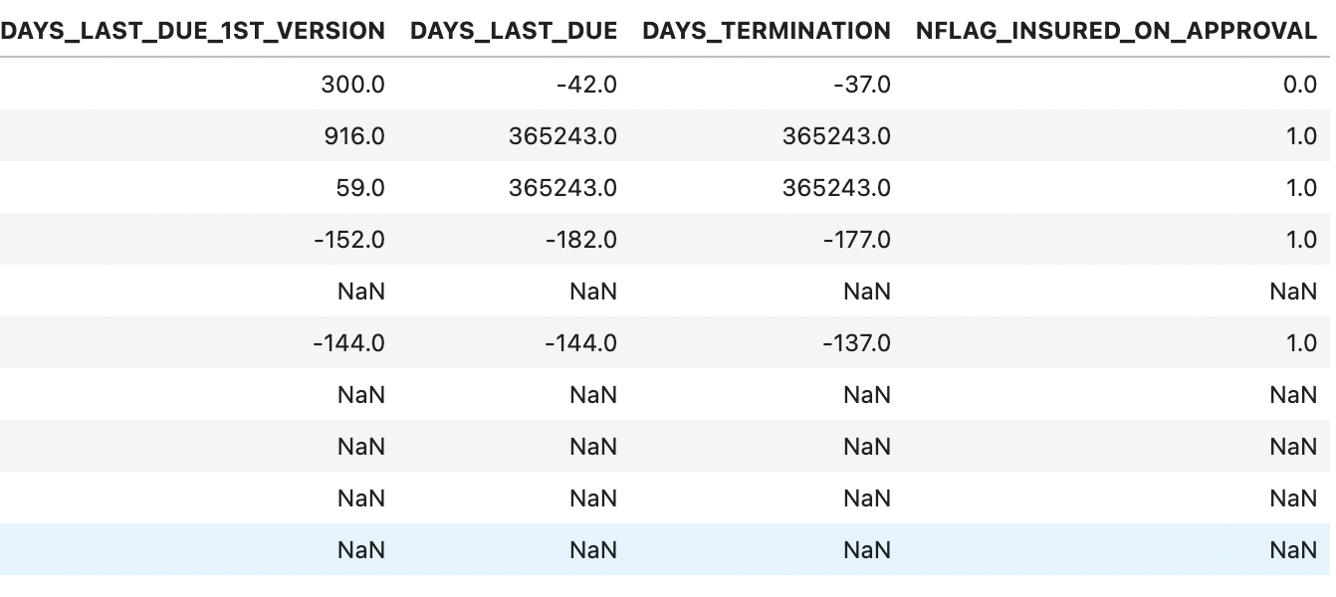

The shape of the dataset is (1670214, 37).

* **DATA PRE-PROCESSING**:

The first step in data preprocessing is to identify the number of null values in each column and eliminating unnecessary columns.

According to the images below it would be appropriate to consider dropping columns with more than 60 percent null values. This would bring the shape of the data set to (1670214, 35). It can be inferred that only two columns possessed more than sixty percent null values and they are eliminated.

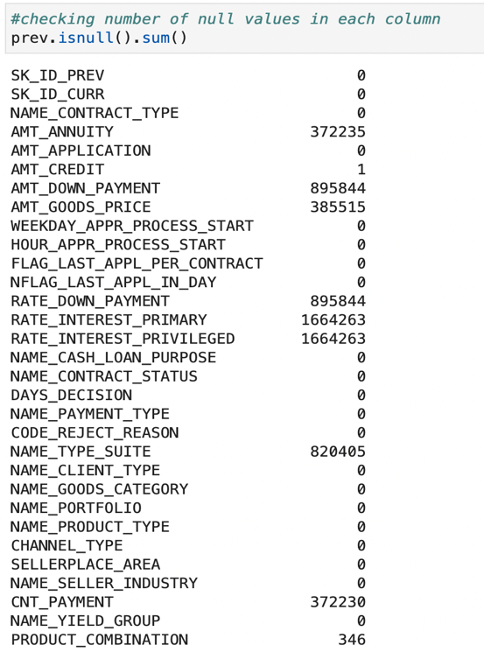

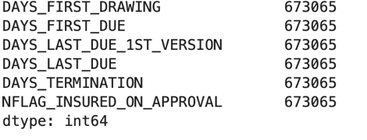

* **DATA ANALYSIS:**

The next step involves identifying the data types of all the columns that are going to be used in data analysis so appropriate matplotlib chats and methods can be used for better and precise visualization.

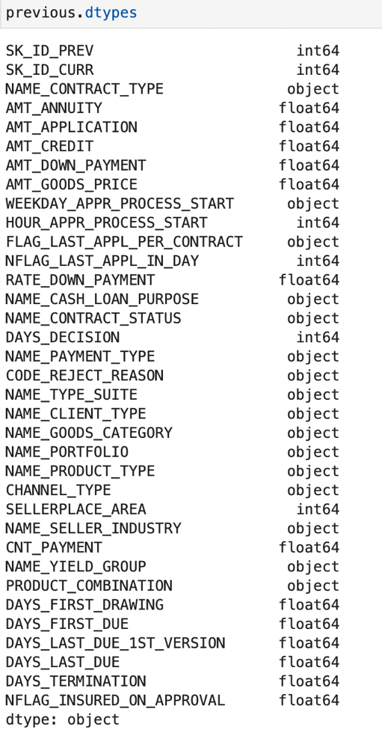

* UNIVARIATE CATEGORICAL FEATURES ANALYSIS:

Univariate categorical data contains only non-statistical data that can be divided into set number of categories with labels. In the current dataset only five univariate categorical features contribute to the analysis and are thus utilized in analysis.

1. Analysis of NAME_CONTRACT_TYPE:

The column refers to the type of loan the clients are applying to. The loan types include: Cash, Consumer, and Revolving Loans.

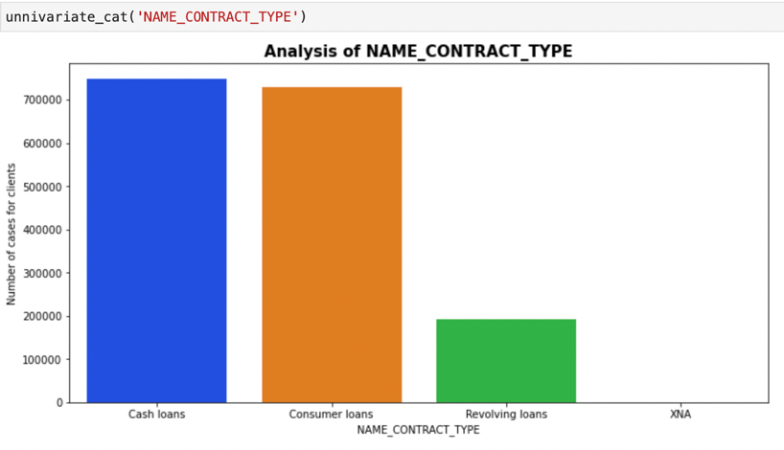

From the bar chart, it is clear that cash loans and consumer loans are more preferred over revolving loans with the applicants.

1. Analysis of WEEKDAY_APPR_PROCESS-START:

The column refers to the day the application is filled and submitted. From the graph is can be observed that Sunday has seen the least number of applications compared to the other days. Also the trend of applications remain same for all six days unanimously.

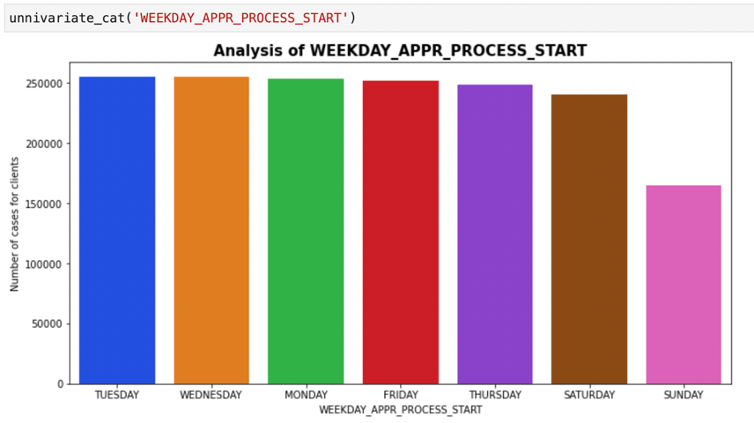

1. Analysis of NAME_CASH_LOAN_PURPOSE:

The column refers to the stated reason in the application as the purpose of the loan. Nothing can be inferred from the data as most decided to state the reason as “XAP”.

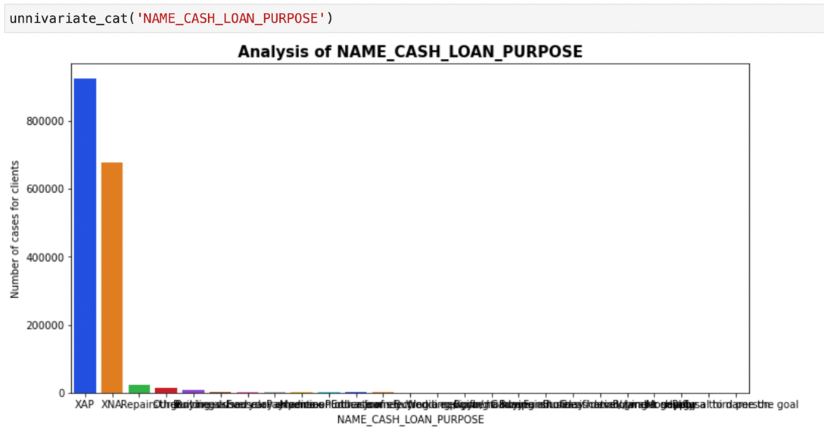

1. Analysis of NAME_CONTRACT_STATUS:

The column refers to the status of the applications the clients have filled. The status can be Approved, Cancelled, Refused and Unused offer. This column is the target of our dataset. It can be observed that the approval rate is generally high from the graph.

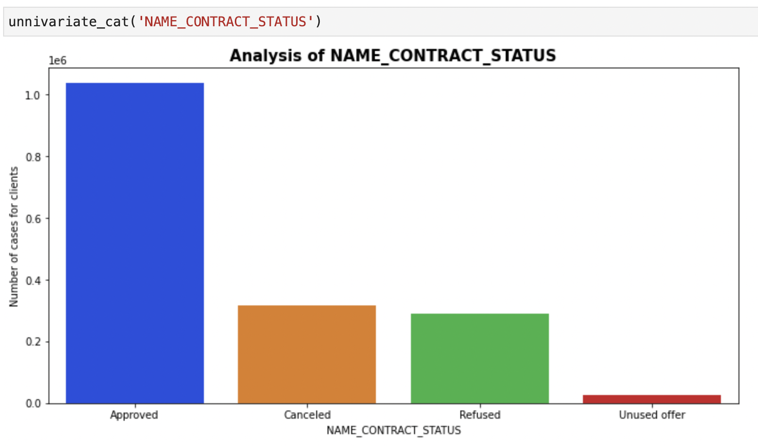

1. Analysis of NAME_PAYMENT_TYPE:

The column refers to the kind of payment used by the clients while returning money back to the bank. It can be stated that the cash is the main source of payment.

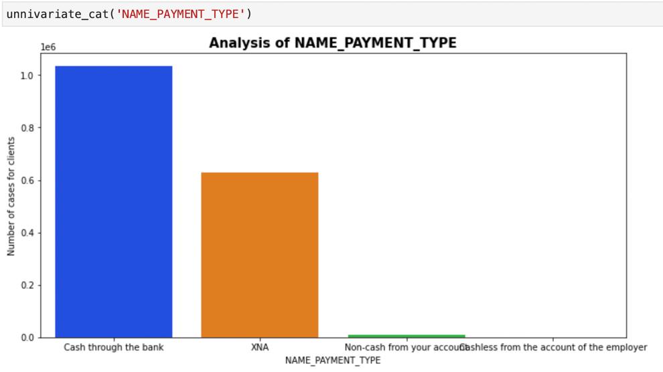

* UNIVARIATE CONTINUOUS FEATURES:

Univariate continuous data consists of a series of numerical or non-numerical data that cannot be categorized into set number of sections or labels and are continuous in nature.

1. Analysis of AMT_CREDIT:

“Alternative minimum tax credit is a reduction given to individuals who have paid alternative minimum tax in previous years.” -ESO Fund. Utilizing AMT Credit gives a chance at accurate prediction of range within which it can be determined whether the applicant is risky or not.

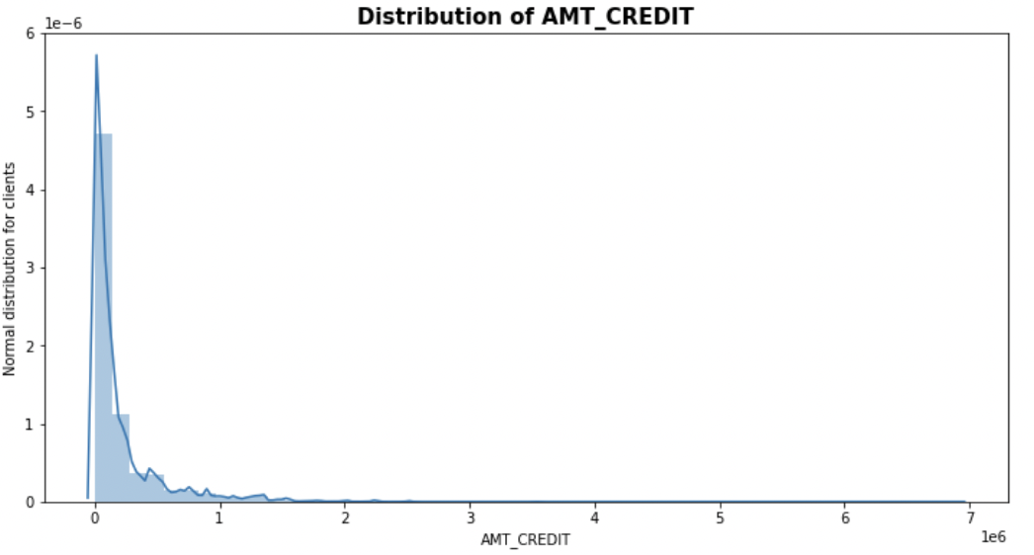

1. Analysis of AMT_ANNUITY:

Annuity is the amount provided to individuals for the rest of their lives. Usage of Annuity in estimation of the clients capability of paying back the loan can be a determining statements.

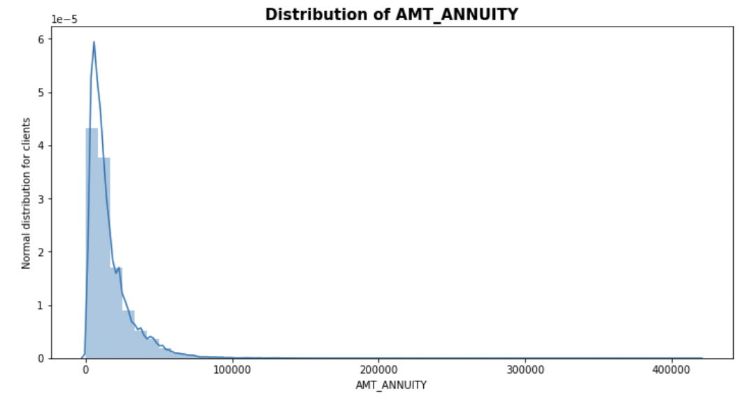

* BIVARIATE ANALYSIS CATEGORICAL-CATEGORICAL:

Bivariate analysis is a statistical analysis of two variables plotted against each other. In this case both the variables are categorical and observed with respect to each other.

1. Analysis of NAME_CONTRACT_TYPE, NAME_CONTRACT_STATUS:

The columns used describe the loan application status and the kind of loan the client is applying for. It can be inferred that consumer loans are approved most compared to others.

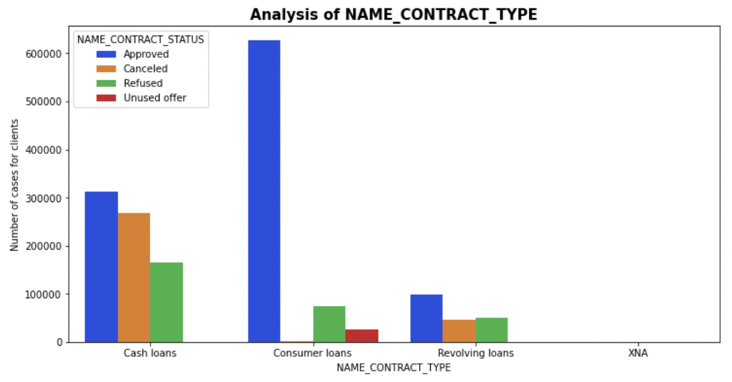

1. Analysis of WEEKDAY_APPR_PROCESS_START, CODE_REJECT_REASON:

The columns represent the weekdays the reasons the applications were rejected. It can be inferred that Sunday has less number of cases than the others and the trend in other days remain relatively same.

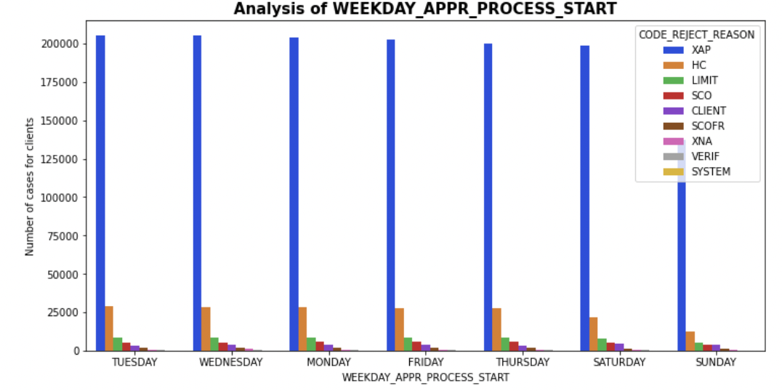

1. Analysis of WEEKDAY_APPR_PROCESS_START, NAME_CONTRACT_STATUS:

The columns represent weekdays and the loan status. It can be seen that the trend seems the same for all days with little differentiation in Sunday.

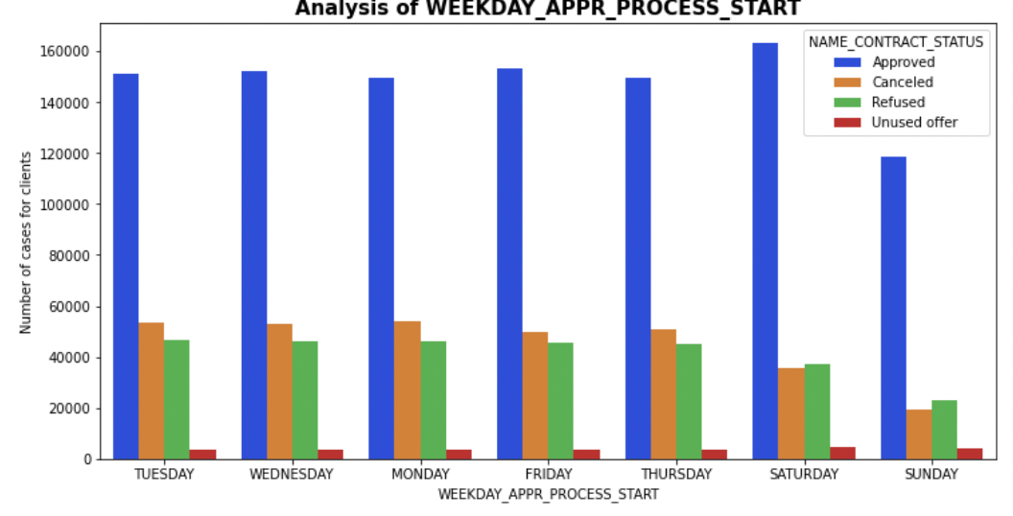

1. Analysis of NAME_PAYMENT_TYPE, NAME_CONTRACT_STATUS:

The columns represent the kind of payment used to pay back the loaned amount and the status of the loan application. It can be inferred that cash through the bank is the main source of payment method for approved loans.

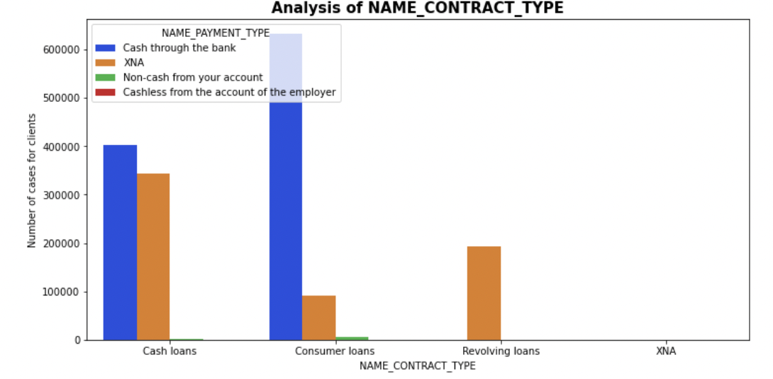

1. Analysis of NAME_CONTRACT_TYPE, NAME_PAYMENT_TYPE:

The columns represent the type of loans applied and the ways through which the payment is made.

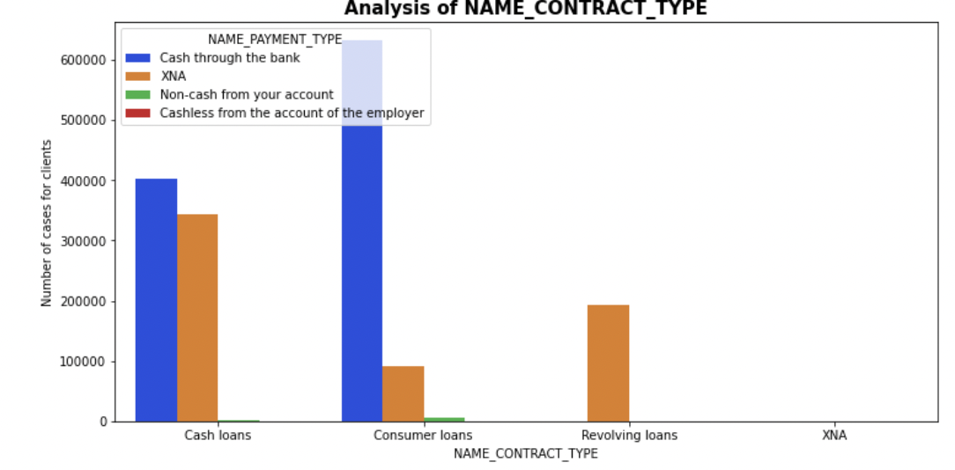

* Bivariate Analysis of Categorical-Continuous Features:

Bivariate analysis is conducted on two features identifies as continuous and categorical.

1. Analysis of NAME_CONTRACT_TYPE, AMT_APPLICATION:

The columns represent the kind of loan applied and the number of amt applications. It can be stated that the cash loans possess higher amount than revolving loans.

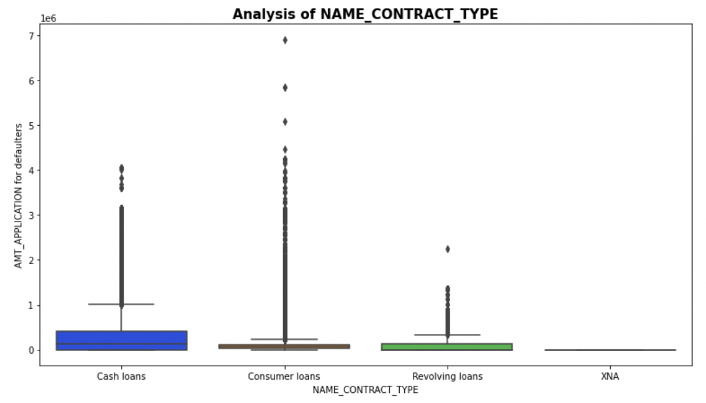

1. Analysis of NAME_PAYMENT_TYPE, AMT_CREDIT:

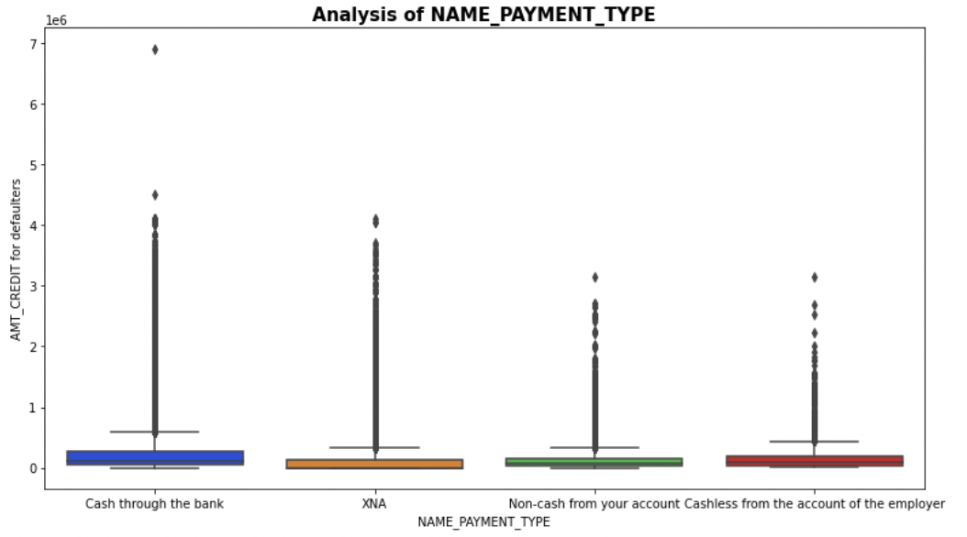

1. Analysis of NAME_CONTRACT_STATUS, AMT_APPLICATION:

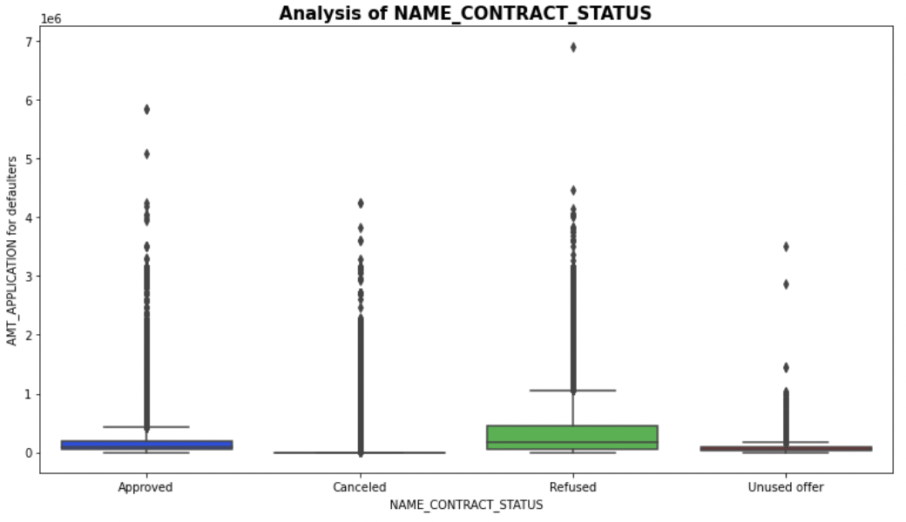

1. Analysis of NAME_CONTRACT_STATUS, AMT_CREDIT

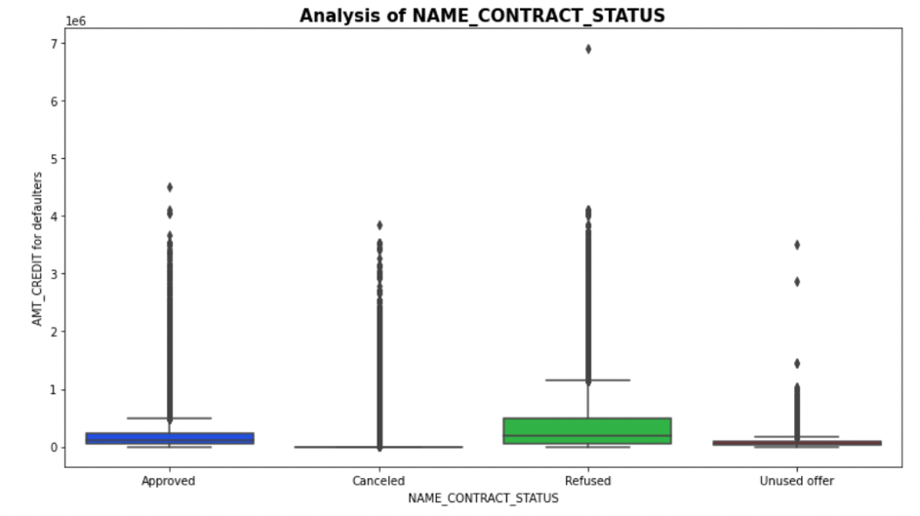

* Bivariate Analysis Continuous - Continuous:

Bivariate analysis is conducted on two features identifies as continuous and continuous.

1. Analysis of AMT_APPLICATION, AMT_CREDIT:

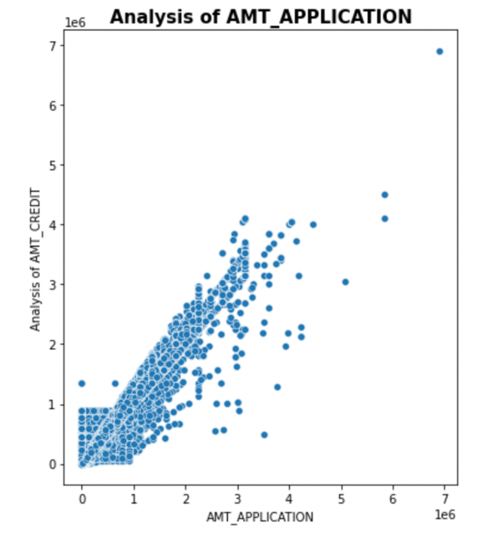

1. Analysis of AMT_APPLICATION, AMT_ANNUITY:

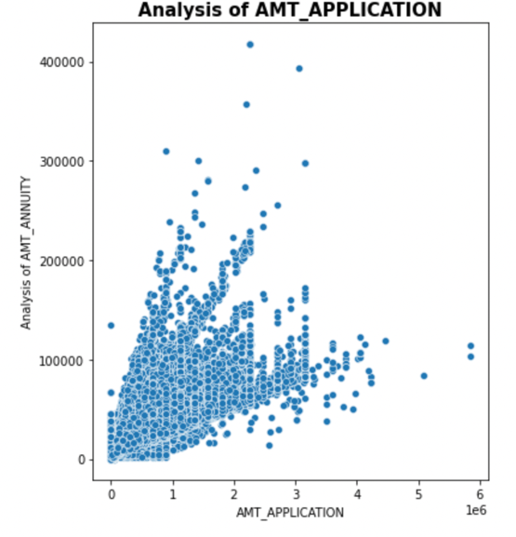

1. Analysis of AMT_CREDIT, AMT_ANNUITY:

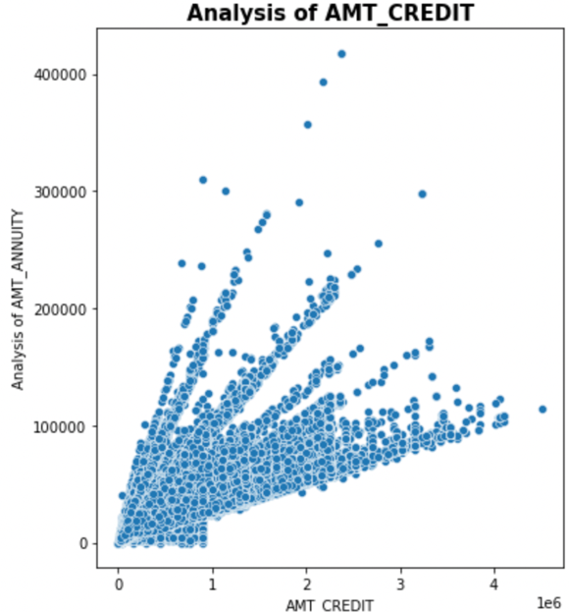

* **Correlation:**

Correlation is used to determine the relationship between variables or features in a dataset and can help in determining the columns that needs to selected for building a model of prediction. 'NAME_CONTRACT_TYPE', 'NAME_CASH_LOAN_PURPOSE', 'NAME_PAYMENT_TYPE', 'AMT_APPLICATION', 'AMT_CREDIT', 'CODE_REJECT_REASON'- The prior columns are used for building a correlation map for better visualization and the top correlations are determined.

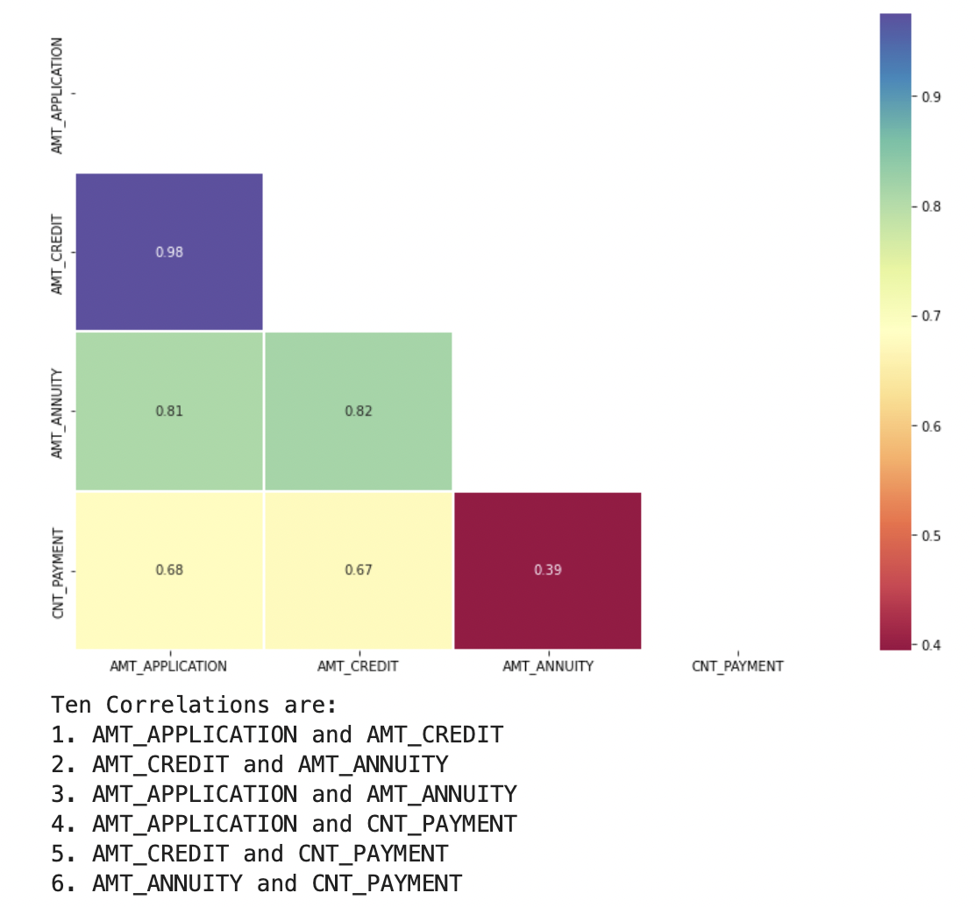

* **Data Manipulation:**

1. Since the columns selected is a mixture of Continuous and Categorical features, introducing dummies would equate the imbalance of the data. The inculcation of dummies increase the number of columns bringing the shape to (1670214, 44).
2. The target column is considered to be the NAME_CONTRACT_STATUS which provides the information of whether an application got approved or not. This data is highly imbalanced with most value counts leaning on Approved status.

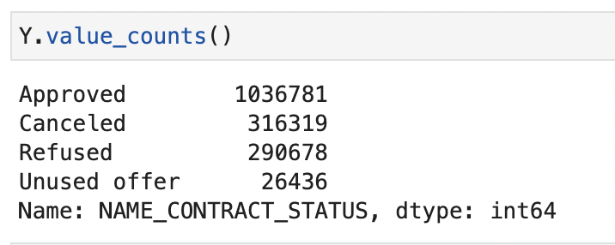

To solve this imbalance, combining the Cancelled, Refused and Unused Offer sections seem plausible since all the three sections mean the same: The client didn’t receive the loan or money from the bank or debt issuing organization. This would bring the Value count of Y to:

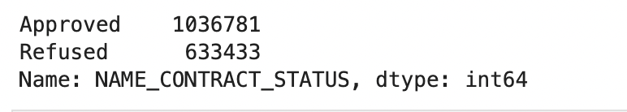

Though the figure improved from the previous numbers, the imbalance is still evident. To overcome this, it is suggested to over-sample the dataset.

1. Over-sampling means duplicating the data which is minority to balance the disparities of a dataset.



The data is now ready for building a model.

* **Algorithms:**

1. **Logistic Regression:**

An approach that is frequently utilized to address binary classification issues is logistic regression. In a model of logistic regression:

* To generate a number between 0 and 1, we use a linear combination (or the weighted sum of the input attributes) and the sigmoid function.
* This figure indicates the likelihood that the input will be categorized as "Yes."

The findings are evaluated using the cross-entropy loss function rather than RMSE.

The following formula describes the sigmoid function when applied to a linear combination of inputs:

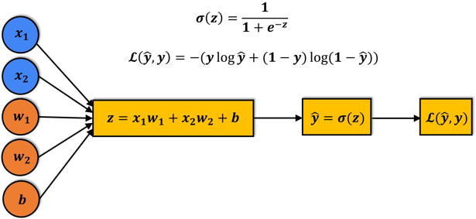

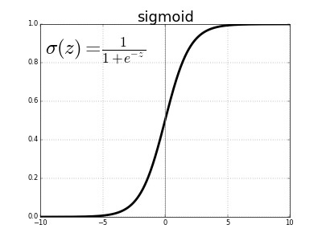

Logistic regression gets its name from the logistic output of the sigmoid function.

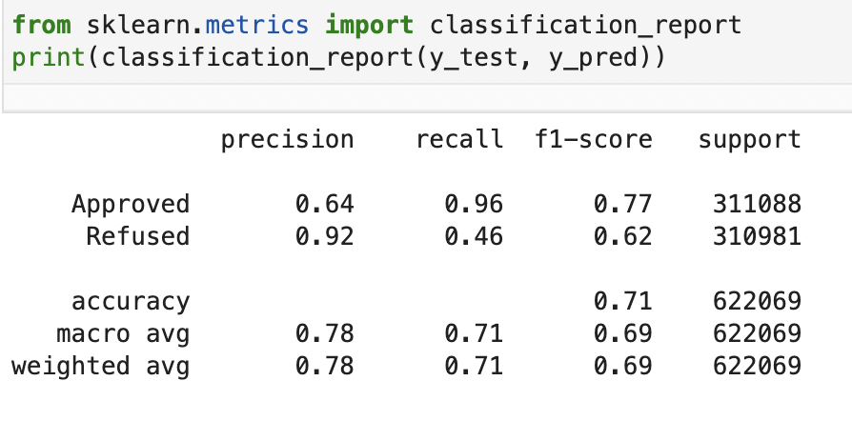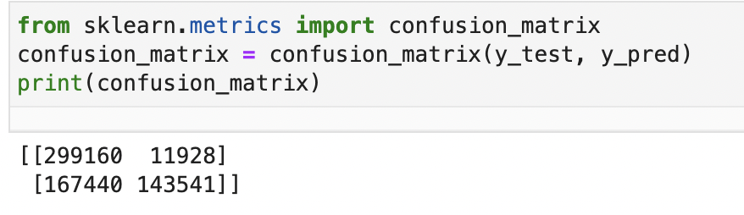

The above diagrams give the confusion matrix and the classification report obtained for the dataset credit analysis through a Logistic regression model.

1. **Decision Tree Classifier:**

The supervised machine learning algorithm called Decision Tree uses a set of principles to make judgments, much like how people do. This machine learning classification algorithm can be thought of as being created to make decisions. The model is typically said to forecast the class of the previously unseen input, but in reality, the algorithm must choose the class to be assigned. Decision trees are otherwise called CART since they could perform both classification and regression. The basic idea behind it is to keep building yes/no questions and branch out, building a tree until all the datapoints and conditions are pin-pointed and decided. A question inevitably spilts the dataset in terms of features and creates new branches or nodes. The image below explains the dataset of a family budgets and is eventually split according to the question posed.

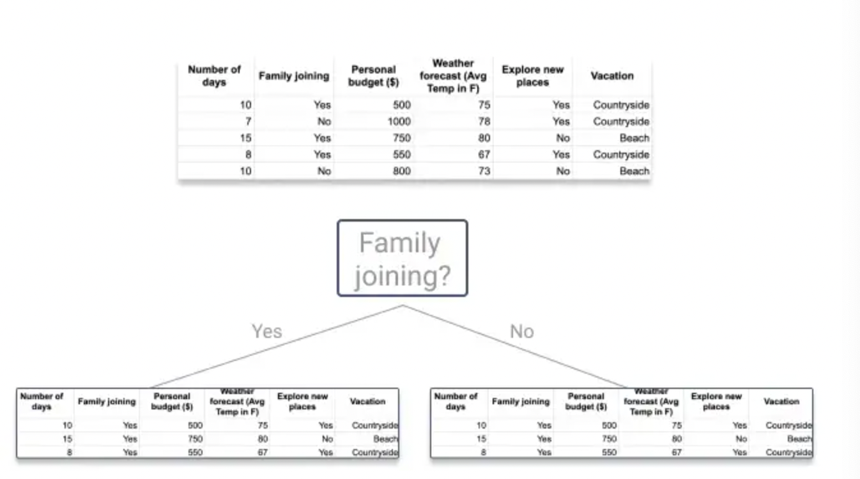

The algorithms keep creating new datasets according to the questions and split data. It’s hard to build a ideal tree that is a tree with very few spits or questions and can classify the data points with utmost accuracy. Building a ideal tree requires unnatural amount of time and keeps increasing with the dataset. So it is best to focus on one node at a time and decide what is the unique and helpful in that particular node. Decision trees are preferred because they require no pre-processing, visualizing of data is easier and more efficient and data robustness is very high in this algorithm. The below figure displays the accuracy and confusion matrix.

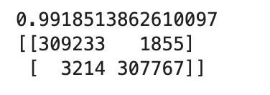

1. **Naïve Bayes Classification:**

Bayes Theorem is a way to measure the probability of a subset of a data belonging to a particular class considering the possessed previous knowledge. Here

Bayes Theorem : P(class|data) = (P(data|class) * P(class)) / P(data)

Here P(class|data) is the probability described before. An approach for categorizing issues with binary (two classes) and multiple classes is called Naive Bayes. Because the probabilities for each class are calculated in a simple manner to make them tractable, it is known as Naive Bayes or idiot Bayes. The probability of each attribute value are presumed to be conditionally independent given the class value rather than trying to compute them. The idea that the qualities do not interact is a very strong assumption that is highly improbable given actual data. However, on data where this assumption is false, the method works surprisingly well.

The below diagram is the confusion matrix of the credit_analysis dataset run in the naïve bayes machine learning model.

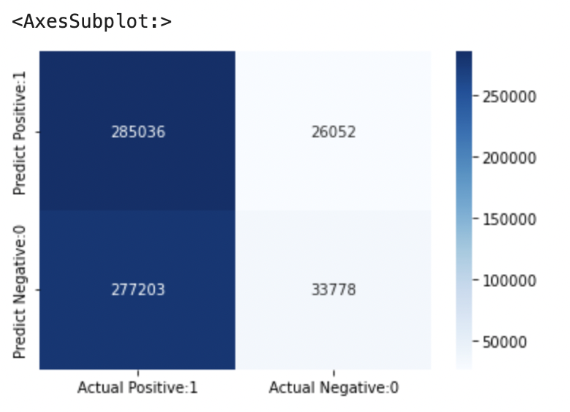

The below diagram describes the classification report of the taken dataset.

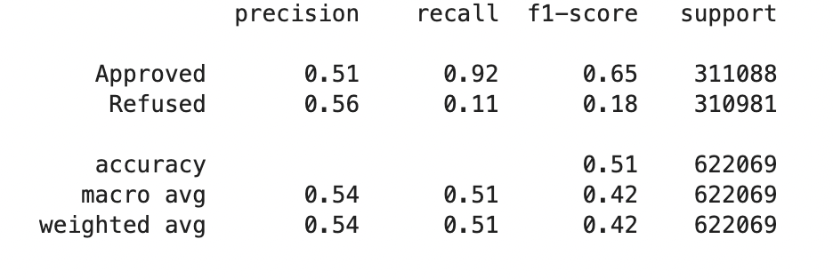

The below numbers are the obtained different accuracies.

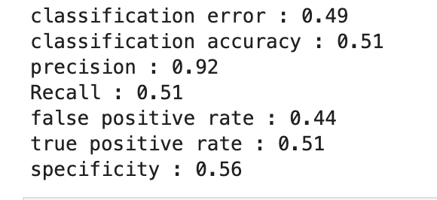

1. **XGBClassifier:**

A gradient boosting architecture serves as the foundation for XGBoost. Machine learning techniques like gradient boosting are used to solve classification, regression, and clustering issues. In order to make predictions, the model is optimized. With this method, various models are combined to do a single task. Weak learners refers to the foundation models. They operate under the premise that a weak learner provides subpar predictions when acting alone but superior predictions when acting as a team. Based on weak learners, XGBoost develops strong learners. It adds models in order. In order to get an optimum solution, the mistakes of the weak models are therefore addressed by the subsequent models in the chain. Ensembling is the term for this. The below diagram displays the Mean cross-validation score, K-fold average scire, Model Accuracy score, classification report and the confusion matrix of the XGB machine learning model. To work with XGBoost Classifier the target Y should be converted from Approved, Refused to 1, 0.

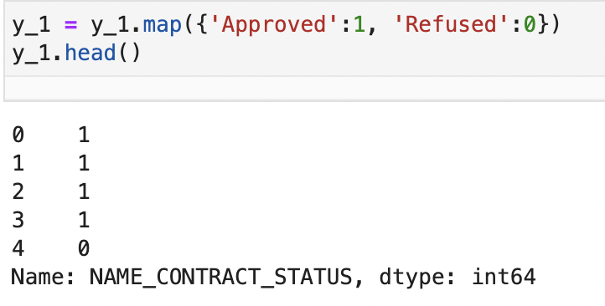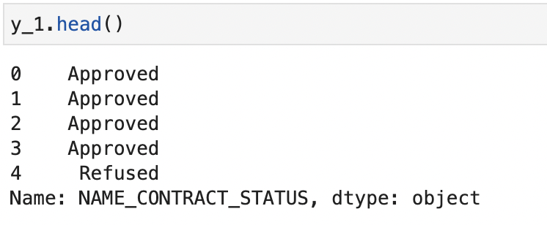

The Accuracies and Classification Report:

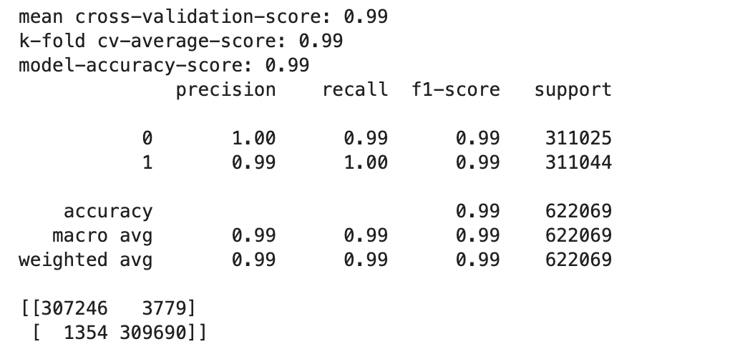

* **Data Description:**

Link: <https://www.kaggle.com/datasets/kapoorshivam/credit-analysis>

The dataset is obtained from Kaggle, named “Credit Analysis”. It is a dataset detailing the previous and present data of loan applications from an unnamed bank utilizing Risk Analytics. The link contains two datasets called current and previous both consisting a data spanning over credit information. The current dataset consists of 122 columns while previous contains 37 columns. The previous dataset details multitude of categories describing the credit card and usage information, personal details, economic, regional and educational background, medical and criminal history and finally the employee’s opinion of the clients. Comparing the datasets, previous is producing more accurate and relatable results and is thus selected as the main dataset.

* **RESULTS AND ANALYSIS**

|  |  |
| --- | --- |
| **CLASSIFIER** | **ACCURACY** |
| LOGISTIC REGRESSION | 0.71 |
| NAÏVE BAYES CLASSIFICATION | 0.51 |
| DECISION TREE CLASSIFIER | 0.99 |
| XGBOOST CLASSIFIER | 0.99 |

* **Conclusion:**

Credit analysis is method of predicting whether an application for approval will go through or not. Four machine learning models were designed with popular and highly praised algorithms. These are Logistic regression, Naïve Bayes Classification, Decision tree classifier and XGBoost classifier. Comparing all the analysis and accuracies of the four machine learning models used in the project it can be concluded that Logistic Regression is an accurate model for accomplishing the goals for this project. Though the accuracy of Decision tree classifier and XGBoost classifier is more than 99 percent, it is practically not possible for this kind of results to exist when it comes to prediction and is thus eliminated. The accuracy score of Naïve Bayes classification is great with around 50 percent but still pales in comparison to Logistic regression accuracy score. The score of 71 percent is a decent accuracy value with enough space to make accurate predictions and not become unrealistic. The model is designed to predict the rate of approval of loan applications which in turn reduces the burden on bank or debt inducing organizations employees and the clients who are worthy of loans and clients who deserve a loan due to their circumstances. The model constructed checks all the conditions set in the goals satisfactorily and has the ability to developed further with greater scope and much larger dataset for more accurate model building.

**REFERENCES:**

[1]<https://www.datasciencelearner.com/svm-classifier-sklearn-implementation-python/>

[2]<https://towardsdatascience.com/beginners-guide-to-xgboost-for-classification-problems-50f75aac5390>

[3] <https://machinelearningmastery.com/naive-bayes-classifier-scratch-python/>

[4]<https://towardsdatascience.com/decision-tree-classifier-explained-in-real-life-picking-a-vacation-destination-6226b2b60575>

[5] <https://www.datatechnotes.com/2019/07/classification-example-with.html>

[6]<https://www.analyticsvidhya.com/blog/2022/02/loan-approval-prediction-machine-learning/>

[7]<https://www.investopedia.com/terms/c/creditanalysis.asp#:~:text=Credit%20analysis%20evaluates%20the%20riskiness,investing%20in%20that%20particular%20entity>.